**BOOK SHOP IN C++**

**Objective:**

Under any particular book shop, there are various number and types of books available and it is sometimes even difficult for the book shop owner to remember the details of any particular book. With this new book shop system, book shopkeeper will find easier to perform all the operations which are needed for their daily business transactions. As there will be a common system and screen for all types of users but to perform operations related to admin part, that person should have a valid login id and password.

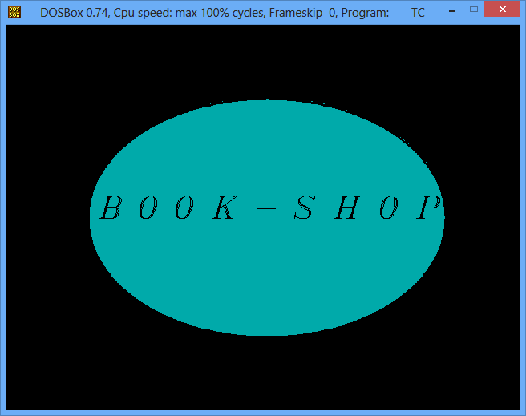

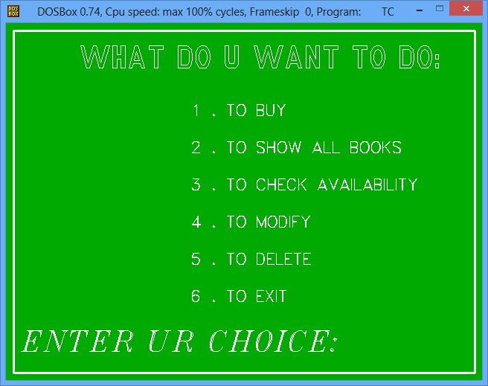

If any customers have purchase any book, then they have to just the correct option and enter the name of the book which they want to book along with total number of books. If the book will be available in the shop, it will generate the final bill which is to be paid by the customers at the cash counter and receive that particular book. If no such book will be available, then appropriate message will be displayed for the users and expected date by which this book will be available within the shop. Admin will have the responsibility to add, delete and modify records related to book such as book name, quantity available, price per book etc.

**Existing System:**

Under the existing system, customers do not have the freedom to use the system within their shop. Only shopkeeper has the facility to use the computer to get information on the basis of customer’s requirements and as per the business requirement. In this system searching medium was not available, by which admin have to get details of book by viewing each book record one by one. As there was sequential method to use any particular records, so making any operations was time consuming and confirmation was not given upon processing any particular task., by which admin have to check manually whether the task has been processed or not.

**Proposed System:**

The new system uses the concept of binary search method to make searching process faster and provide results within short interval of time. As each modules has been divided into class and functions, so the execution time of this system is optimized as compared to the previous system. To make data secure and maintain data integrity proper mechanism has been used to perform validation process at the client side before saving any data and information to a particular file. Users will be provided with friendly screen, whether they have to just few information’s regarding their query and all processing work will be done at the back side.

